FACTORIAL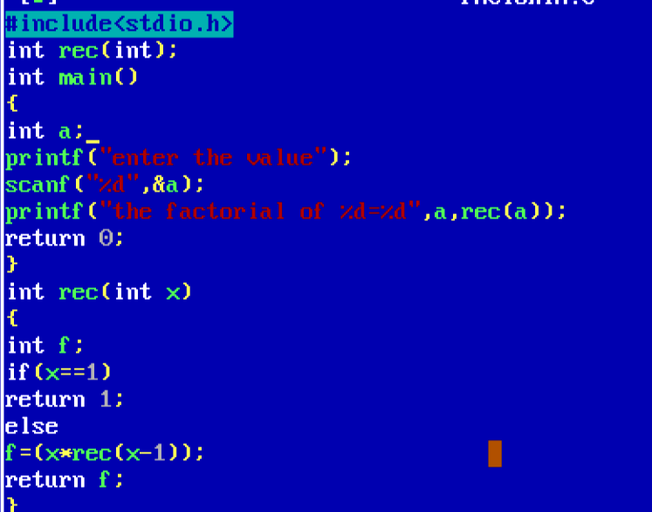

OUTPUT

